**CMPE 295 A**

**Prof. Kaikai Liu**

**Project: Sustainable Fashion Recommendation Application using Machine Learning**

**ML Deployment**

**ML Deployment Architecture :**

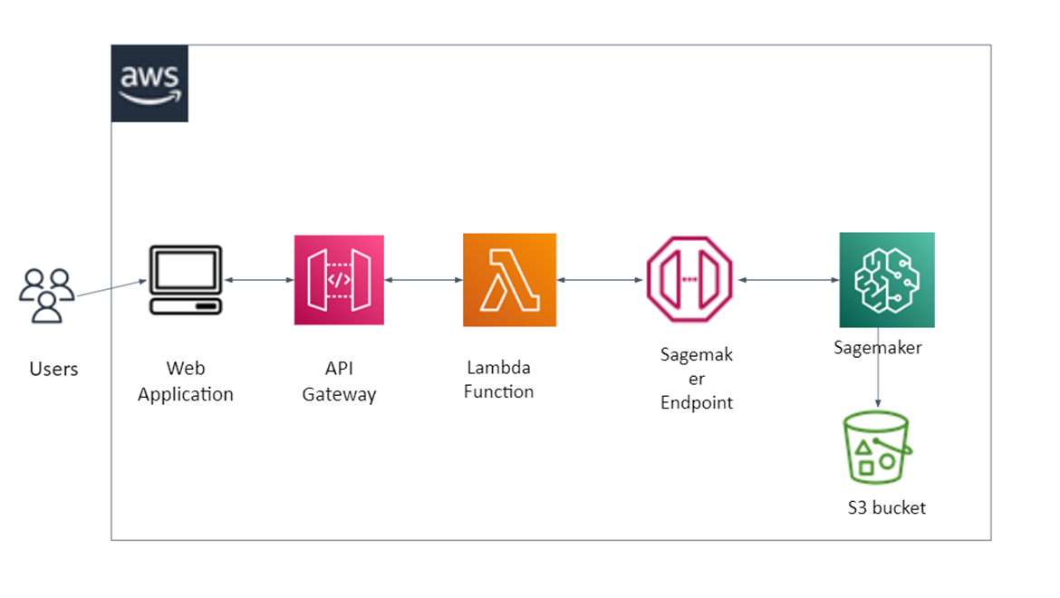

Figure 0 ML Deployment Architecture Diagram

**Tech Stack:**

1. AWS Sagemaker
2. Lambda Functions
3. APT Gateway
4. Boto3
5. Jupyter Notebook
6. Python
7. S3

**Description:**

As shown we are going to deploy the trained model to AWS Sagemaker. AWS Sagemaker is a web service that is used to train, test and deploy the machine learning model and is integrated with Jupyter Notebook.

* Once, we trained models. We will be deploying it to AWS Sagmaker.
* For deployment, we need to upload a trained model file to Sagemaker, and deployment includes configuring Sagmaker Endpoint, creating it.
* For uploading model artifacts and holding other files like training dataset, training data, etc. we are going to use S3 bucket.
* For interaction with all AWS services, we are going to use Boto3 which is Python SDK for AWS.
* When we get Sagemaker Endpoint, we will create a serverless service with help of Amazon API Gateway and AWS Lambda Function to trigger/invoke Sagemaker Endpoint from the Front-end of the hosted Web Application.
* For testing the API, we can use Postman/ can do end to end testing.
* In this way, users will be able to interact with the Machine Learning component.

**Steps Followed:**

The document has the screenshots of AWS Setup. Please see the following steps.

* Train the ML Model Locally
* Create a Sagemaker Notebook instance
* Create a Sagemaker Endpoint
* Create A Lambda Function
* Create API Gateway REST API

1. **Train the ML Model Locally.**

Please refer to the code uploaded on Project Github. The model is trained locally on Jupyter Notebook.

<https://github.com/shreyaghotankar/CMPE295-Masters_Project/blob/master/datacleaning/models/knnmodel/KNN.ipynb>

1. **Create a Sagemaker Notebook instance:**

Sagemaker setup in AWS:

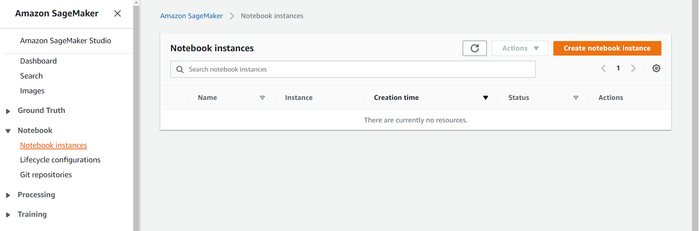

Figure 1

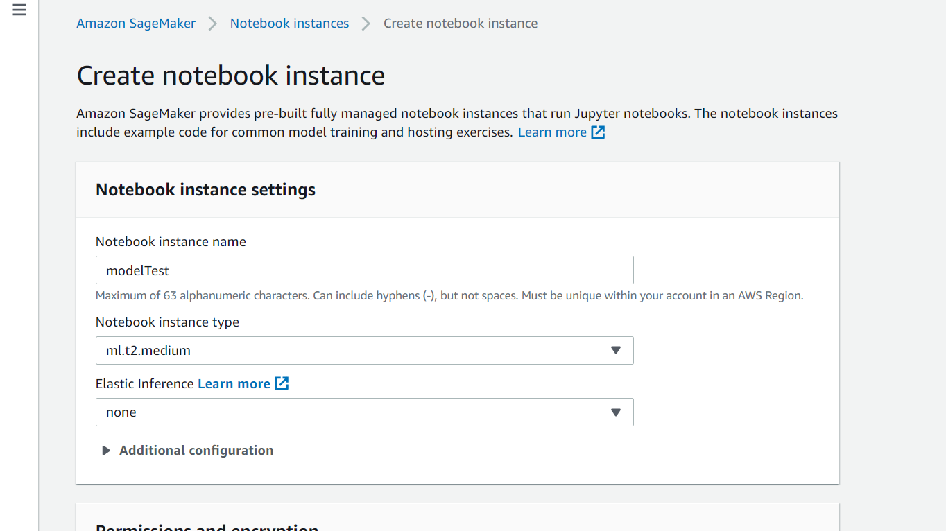

Figure 2

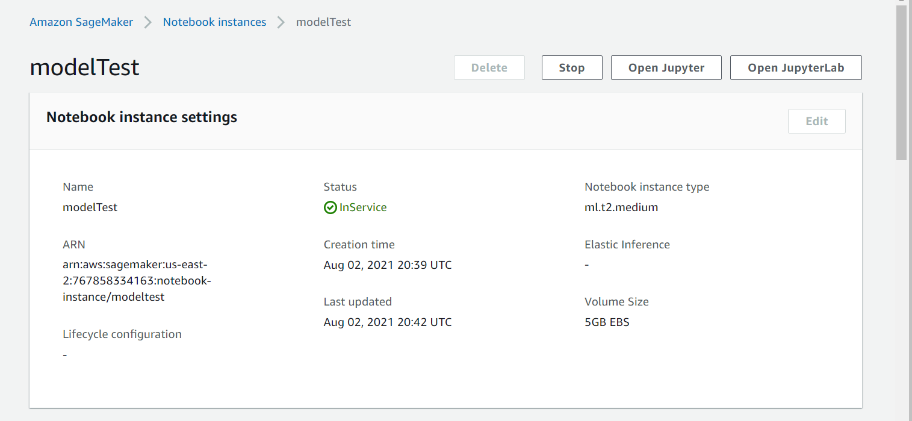

Figure 3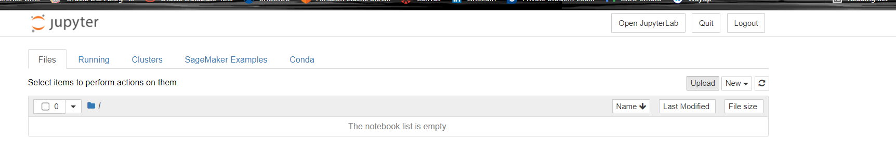

Figure 4

**C) Create a Sagemaker Endpoint:**

* Please refer <https://github.com/shreyaghotankar/CMPE295-Masters_Project/blob/mlDeploy/datacleaning/deployment/KNNdeployment.ipynb>
* Created Sagemaker Endpoint:

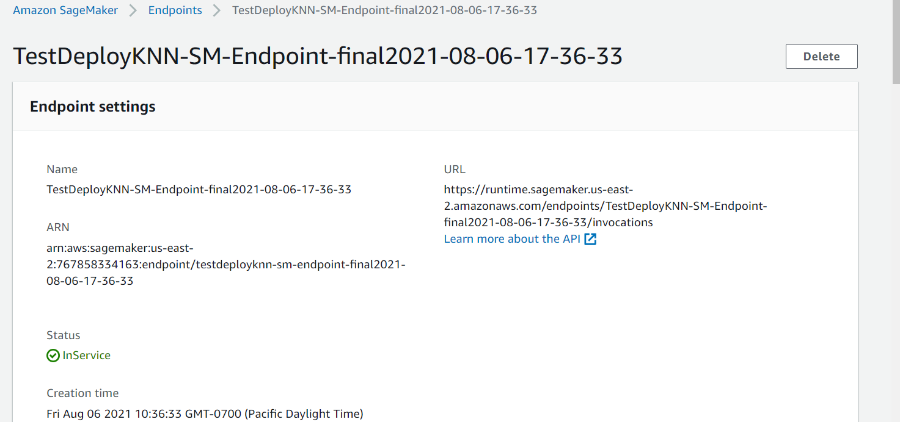

Figure 5

**D) Create A Lambda Function:**

* AWS Lambda function setup:

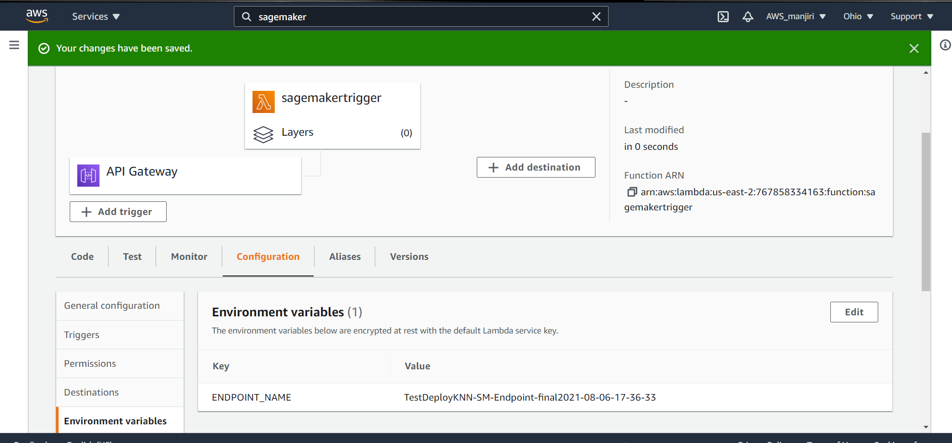

Figure 6

**E) Create API Gateway REST API**

* API Gateway setup

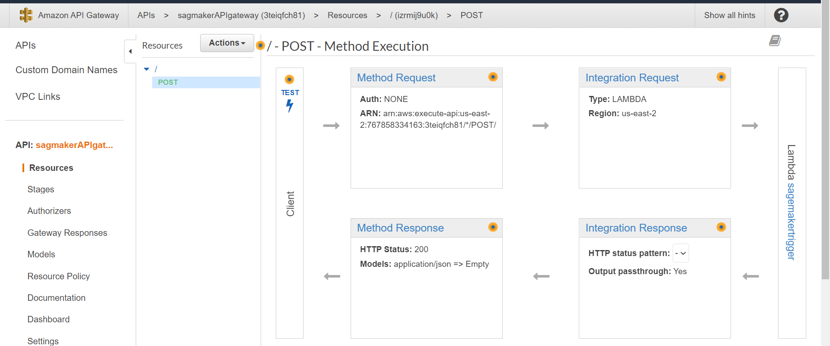

Figure 7

**References:**

* [**https://aws.amazon.com/getting-started/hands-on/semantic-content-recommendation-system-amazon-sagemaker/5/**](https://aws.amazon.com/getting-started/hands-on/semantic-content-recommendation-system-amazon-sagemaker/5/)
* **https://aws.amazon.com/sagemaker/**